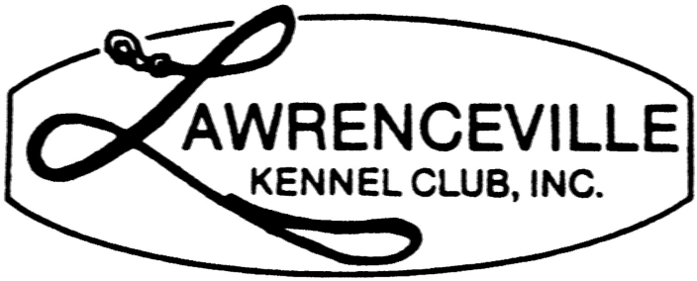
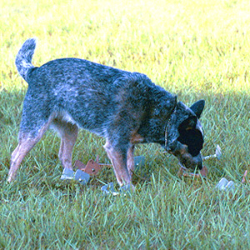
DETECTION
SEMINAR
BY MARK LEAMER

Mark began training dogs in 1973 while stationed in Germany with the U.S. Army. Starting in 1976, he worked in law enforcement where he handled and trained several police K-9s. In the last 25+ years, Mark has provided police K-9s, handler training and consulting to 15 law enforcement agencies in the state of Georgia. Mark’s training methods for narcotics detection has produced highly reliable and effective dogs for law enforcement.

SATURDAY APRIL 27, 2019 11:00 AM – 2:30 PM
Seminar and Demos by Local Law Enforcement
11:00 AM to 12:30 PM
Lunch available 12:30 to 1:00 PM
Working Session 1:00-2:30 PM

SEMINAR AND LUNCH $40
10 WORKING SPOTS AVAILABLE $80
(Spots assigned on a first come basis)
DETECTION SEMINAR BY MARK LEAMER Saturday April 27, 2019
LKC Training Facility, 2156 Oakland Industrial Court, Lawrenceville, GA 30044

Mail registration and payment to:
LKC DETECTION SEMINAR c/o Judy Wilson, 200 Hayward Lane, Lawrenceville, GA 30044

Deadline to registration is April 24, 2019.
Make Checks/Money Order payable to Lawrenceville Kennel Club

Name_______________________________________________________________________________

Address______________________________________________________________________________
City/State/Zip_________________________________________________________________________
Contact Number_______________________________Email____________________________________
Choose One: Seminar & Lunch only $40___________Seminar, Lunch & Working Spot $80_______________
Questions? Email wheelerb32@yahoo.com

